Art, Craft and Design Long-Term Plan

 | Autumn Term |  | Spring Term |  | Summer Term
 | Cycle A | Cycle B | Cycle A | Cycle B | Cycle A | Cycle B
Reception | Drawing: Marvellous marks (6 lessons)  https://www.kapowprimary.com/subjects/art-design/art-and-design-reception/reception-units/drawing/ | Drawing: Marvellous marks (6 lessons)  https://www.kapowprimary.com/subjects/art-design/art-and-design-reception/reception-units/drawing/ | Craft and design: Let’s get crafty (Lesson 1-6)  https://www.kapowprimary.com/subjects/art-design/art-and-design-reception/reception-units/craft-and-design-lets-get-crafty/ | Sculpture and 3D: Creation station (6 lessons)  https://www.kapowprimary.com/subjects/art-design/art-and-design-reception/reception-units/sculpture-3d-creation-station/ | Painting and mixed media: Paint my world (Lessons 1 and 6)  https://www.kapowprimary.com/subjects/art-design/art-and-design-reception/reception-units/paint-my-world/ | Painting and mixed media: Paint my world (Lessons 1 and 6)  https://www.kapowprimary.com/subjects/art-design/art-and-design-reception/reception-units/paint-my-world/
Year 1/2 | Y2-Drawing: Understanding Tone and Texture (5 Lessons)  https://www.kapowprimary.com/subjects/art-design/key-stage-1/year-2/drawing-understanding-tone-and-texture/ | painting and mixed media: colour splash (5 Lessons)  https://www.kapowprimary.com/subjects/art-design/key-stage-1/year-1/painting/ | Craft and Design: Woven Wonders (5 Lessons)  https://www.kapowprimary.com/subjects/art-design/key-stage-1/year-1/clay/ | Sculpture and 3D: Paper play (5 Lessons)  https://www.kapowprimary.com/subjects/art-design/key-stage-1/year-1/3d/ | Craft and Design: Map it out (5 Lessons)  kapowprimary.com/subjects/art-design/key-stage-1/year-2/craft-and-design/ | Painting and mixed media: Life in colour (5 lessons)  https://www.kapowprimary.com/subjects/art-design/key-stage-1/year-2/year-2-painting/
Year 3/4 | Craft and design: Fabric of nature (5 Lessons)  https://www.kapowprimary.com/subjects/art-design/lower-key-stage-2/year-4/craft-and-design/ | Drawing: Developing drawing skills (6 Lessons)  https://www.kapowprimary.com/subjects/art-design/lower-key-stage-2/year-3/developing-drawing-skills/ | Craft and design: Ancient Egyptian scrolls (5 Lessons)  https  //www.kapowprimary.com/subjects/art-design/lower-key-stage-2/year-3/craft-and-design/ | Sculpture and 3D: Abstract shape and space  https://  www.kapowprimary.com/subjects/art-design/lower-key-stage-2/year-3/3d-and-sculpture/ | Painting and mixed media- prehistoric painting  https://www.kapowprimary.com  /subjects/art-design/  lower-key-stage-2/year-3  /painting/ | Painting and mixed media- Light and Dark  https://www.kapowprimary.com  /subjects/art-design/lower-key-stage-2  /year-4/painting/
Year 5/6 | Craft and design: Architecture  https://www.kapowprimary.com/subjects/art-design/upper-key-stage-2/year-5/craft-and-design/ | Drawing: Make my voice heard  https://  www.kapowprimary.com/  subjects/art-design/upper-key-stage-2/year-6/drawing/ | Drawing: Expressing ideas  https://www.kapowprimary.com/subjects/art-design/upper-key-stage-2/year-6/updated-drawing-expressing-ideas/ | Sculpture and 3D: Making memorise (5 Lessons)  https://  www.kapowprimary.com/subjects/art-design/upper-key-stage-2/year-6/3d-and-sculpture/ | Sculpture and 3D : Interactive Installation (5 Lesson)  https://www.kapowprimary.com/subjects/art-design/upper-key-stage-2/year-5/3d-and-sculpture/ | Y5 Painting and mixed media- portraits  https://www.kapowprimary.com/  subjects/art-design/upper-key-stage-2/  year-5/painting/

Principles of Art
- Learning Practical, Theoretical and Disciplinary Knowledge
- Learning the curriculum to achieve ambitious goals
- Organising and sequencing components to help pupils acquire knowledge
- Disciplinary knowledge to be at the heart of the subject, shaping curriculum and pedagogical choices.
When considering the knowledge pupils need to learn, know and remember from our Art, Craft and Design curriculum we considered the following three separate strands. By teaching children, the practical and theoretical knowledge that they need in order to produce and discuss artwork, over time, they are able to develop their schema of ‘art’ as a discipline.
Substantive Knowledge |  | Disciplinary Knowledge
Practical Knowledge | Theoretical Knowledge | Disciplinary Knowledge
Allows children to develop technical proficiency through:  - Taught techniques (e.g. shading, printing, collage)  - Media Used (e.g. clay, paint, pencil)  - The formal elements of art (line, tone, shape, colour, form, pattern, texture etc)  - Technical Language  - Principles of Art | Allows pupils to learn about the cultural and contextual content of artists and artwork:  - The history of art and art movements  - Genres, themes, styles  - Artists and art – context and significance  - Meanings and interpretations | Allows pupils to learn about how art is studied, discussed and judged:  - How experts have expressed quality and value throughout history  - What is art? What counts as art?  - Recognising a variety of art can have the same subject matter (difference and similarity)

We have utilised the Kapow Scheme to support with our Art, Craft and Design Curriculum. Our curriculum allows our pupils (as young artists) to consider each of the formal elements carefully when making their artwork.
We recognise that the formal elements are:
Line | Shape | Form | Tone (Value) | Texture | Pattern | Composition | Colour
Line is the path left by a moving point. For example, a pencil or a brush dipped in paint.  A line can take many forms. It can be horizontal, diagonal or curved.  It can also change over its length, starting off curved and ending up horizontal, for example.  Line can be used to show many different qualities, such as:  - contours – showing the shape and form of something  - feelings or expressions – a short, hard line gives a different feeling to a more flowing one  - movements | A shape is an area enclosed by a line.  It could be just an outline or it could be shaded in.  Shapes can be either geometric, like a circle, square or triangle, or irregular.  When drawing shapes, you must consider the size and position as well as the shape of the area around it.  The shapes created in the spaces between shapes are referred to as negative space. | Form is a three-dimensional shape, such as a cube, sphere or cone.  Sculpture and 3D design are about creating forms.  In 2D artworks, tone and perspective can be used to create an illusion of form. | This refers to the lightness or darkness of something.  This could be a shade or how dark or light a colour appears.  Tones are created by the way light falls on a 3D object.  The parts of the object on which the light is strongest are called highlights and the darker areas are called shadows.  There will be a range of tones in between the highlights and shadows. | This is to do with the surface quality of something, the way something feels or looks like it feels.  There are two types of texture: actual texture and visual texture.  Actual texture really exists, so you can feel it or touch it. You can create actual texture in an artwork by changing the surface, such as sticking different fabrics onto a canvas. Combining different material techniques can create interesting textures.  Visual texture is created using marks to represent actual texture. It gives the illusion of a texture or surface but if you touched it, it would be smooth. You can create visual texture by using different lines, shapes, colours or tones. Think about how different marks can be used to show texture. | A design that is created by repeating lines, shapes, tones or colours.  The design used to create a pattern is often referred to as a motif.  Motifs can be simple shapes or complex arrangements. | The term composition means ‘putting together,’ and can apply to any work of art, from music to writing to photography, that is arranged or put together using conscious thought. In the visual arts, composition is often used interchangeably with various terms such as design, form, visual ordering, or formal structure, depending on the context. | Red, yellow and blue are primary colours, which means they can’t be mixed using any other colours. In theory, all other colours can be mixed from these three colours. Two primary colours mixed together make a secondary colour.  Tertiary colours are created by mixing a primary colour and the secondary colour next to it on the colour wheel.  Colour schemes:  Monochromatic - Monochrome means one colour. Artwork can be created that explores the tone and intensity of a selected colour. You can change the tone of a colour by adding its complementary colour or by adding black or white to it. Adding white to a colour creates a tint, and adding black creates a tone. You can also alter the tone of a colour with saturation techniques. This means adding either more paint or more water. The more water that is added the lighter the tone and the more paint the darker.  Limited colour  You can select a limited number of colours and use these to represent different tones. For example, you could pick two complimentary colours, or you could use only the three primary colours. This can create a striking image.
  Primary | Secondary
  red + yellow | = orange
  red + blue | = purple
  blue + yellow | = green
Areas of Making
We recognise that there are 12 areas of making. These are;

Drawing | Painting | Printmaking | Sculpture | Ceramics | Creative Craft | Collage | Textiles | Photography and lens-based media | Installation and site-specific work | Digital and new media | Design and graphic design

In line with the National Curriculum, we focus mainly on the areas of drawing, painting and sculpture. The National Curriculum also specifies ‘Other art, craft and design techniques. The ‘other areas’ we have chosen to include within our curriculum are printmaking, creative crafts and collage. Our curriculum has been designed to ensure that these areas of making are revisited over time, allowing to broaden the curriculum by exploring detail and the various ways that artists and craft makers have expressed these areas of making.

Drawing | Painting | Sculpture | Collage | Creative Crafts | Printmaking
Drawing is fundamental to the development of fine motor skills and visual perception in young children. It allows children to express their ideas and emotions creatively and helps in developing their observation skills. Through drawing, children learn to represent their experiences and surroundings, which is crucial for their cognitive development. | Painting encourages creativity, imagination, and exploration of colour and texture. It provides a medium for self-expression and communication. By using different tools and techniques, children develop their fine motor skills and hand-eye coordination. Painting also offers opportunities for children to understand the properties of different materials and develop their artistic style. | Sculpture enables children to explore three-dimensional space and form. It encourages them to think spatially and experiment with various materials to create tangible representations of their ideas. Sculpture also fosters problem-solving skills and aids in understanding shape, scale, and proportion. | Collage allows children to integrate various materials and textures to create visually stimulating artwork. It promotes creativity, resourcefulness, and the ability to manipulate different materials. Collage also provides opportunities for children to explore composition and develop their aesthetic sensibilities. | Engaging in creative crafts introduces children to a wide range of craft techniques and materials. It nurtures their ability to plan, design, and create tangible objects while sparking their curiosity and imagination. Creative crafts promote fine motor skills, dexterity, and a sense of achievement through the completion of projects. | Printmaking offers children the opportunity to experiment with pattern, repetition, and reproduction. It encourages them to think critically about design and composition while exploring various printmaking techniques. Printmaking also promotes an understanding of the printing process and the impact of colour and texture on the final outcome.

By including these 'areas of making' in our art, craft and design curriculum, we aim to provide a well-rounded artistic education that nurtures creativity, critical thinking, and visual literacy in our students.

Year Group | Specific Artists of Study
Year Group | Autumn Term |  | Spring Term |  | Summer Term
 | Cycle A | Cycle B | Cycle A | Cycle B | Cycle A | Cycle B
Reception | 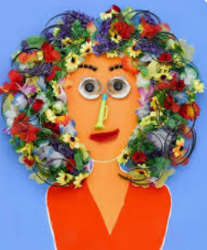  Hanoch Piven.  for creative portrait collages using everyday objects, inspiring pupils to explore materials, shape, and imagination. | 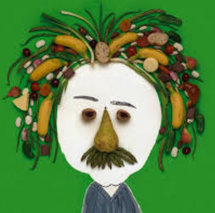  Hanoch Piven.  for creative portrait collages using everyday objects, inspiring pupils to explore materials, shape, and imagination. | N/A | Beth Cavener  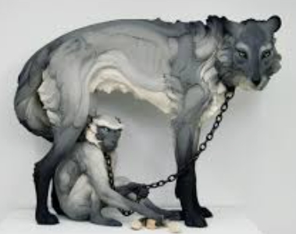  Julie Wilson  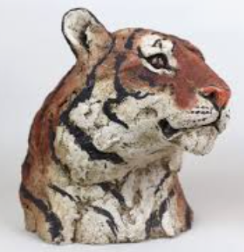  They show emotion and movement in sculpture (Cavener) and creative use of materials and texture (Wilson) | Megan Coyle  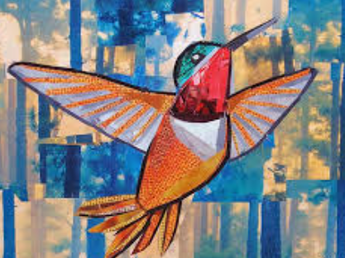  Jasper Johns  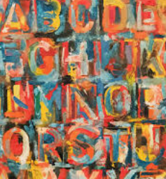  They provide a strong mix of mixed media experimentation (Coyle) and painting techniques (Johns) for the lessons. | Megan Coyle  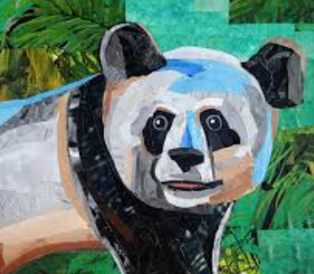  Clarice Cliff  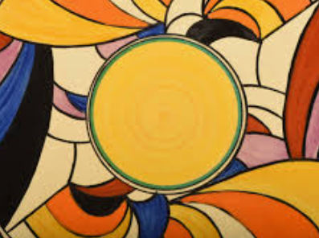  These two give a balance of creative materials (Coyle) and painting techniques with strong colour (Cliff).
Year 1/2 | Kathe Kollwitz  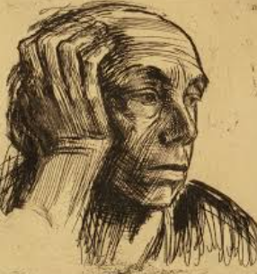  Max Ernst  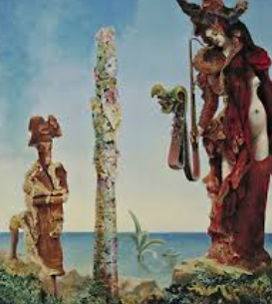  These two give a clear contrast between tone (Kollwitz) and texture/creative style (Ernst), | Clarice Cliff  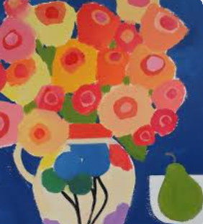  Jasper Johns  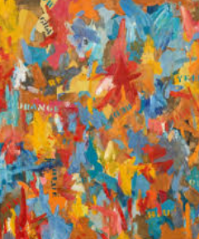  for bold colours and decorative patterns (Cliff) and for layering, texture, and mixed-media techniques (Johns) | Cecilia Vicuña  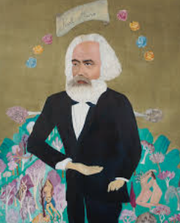  for textile-based and mixed-media work that explores nature, culture, and storytelling | Louise Bourgeois  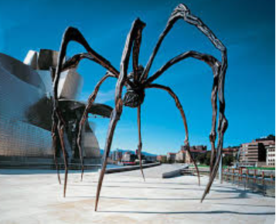  Samantha Stephenson  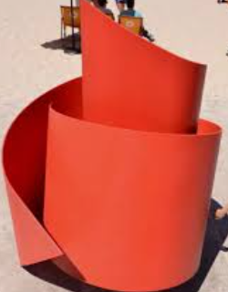  for emotional, abstract sculptures (Bourgeois) and for creative, playful sculpture and installations (Stephenson) | Susan Stockwell  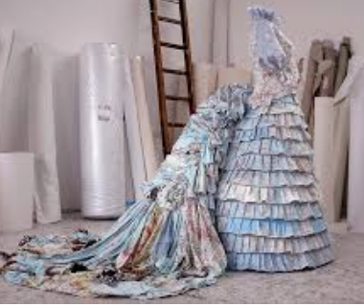  Josef Albers  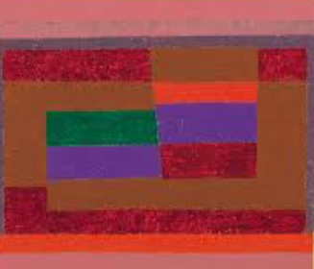  These two provide a balance of creative material use (Stockwell) and design-focused thinking (Albers). | Romare Bearden  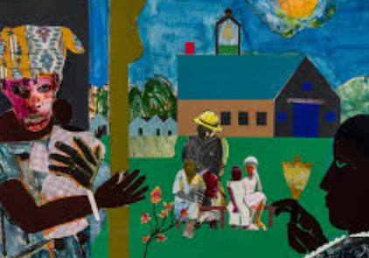  for vibrant, narrative collages that explore culture, community, and storytelling,
Year 3/4 | Megan Carter  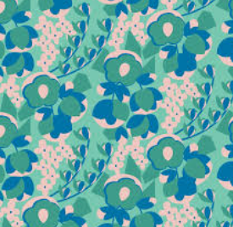  William Morris  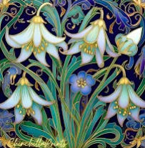  These two give a balance of classic pattern design (Morris) and modern textile creativity (Carter). | Edgar Degas  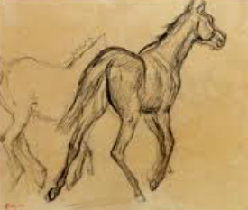  Katie Daisy  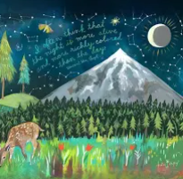  These two give a mix of classical technique (Degas) and modern, playful pattern and colour (Daisy). | N/A | Ruth Asawa  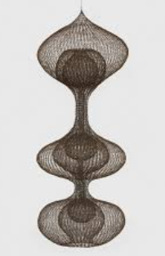  Anthony Caro  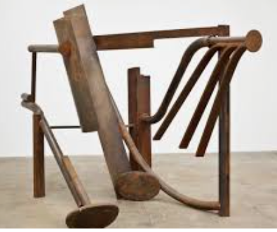  for intricate wire sculptures, teaching pupils about line, form, and 3D structure (Asawa) for large-scale abstract metal sculptures, inspiring experimentation with shape (Garo) | N/A | Leonard da Vinci  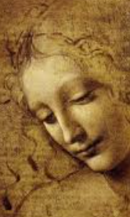  Rembrandt  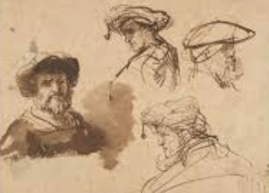  These two provide a strong combination of realistic technique (da Vinci) and expressive light and tone (Rembrandt).
Year 5/6 | Zaha Hadid  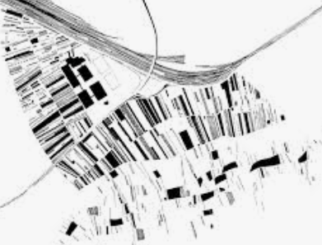  for futuristic, flowing building designs, inspiring pupils to explore curves, bold shapes, and innovative structures. | Leonardo da Vinci  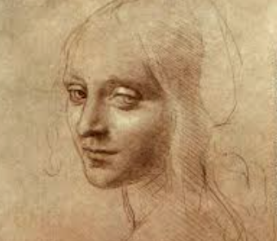  Pablo Picasso 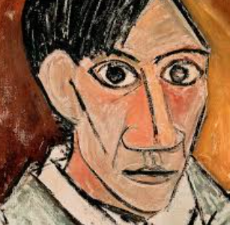  This gives a balance of realistic technique (da Vinci) and creative abstraction (Picasso). | Edgar Müller  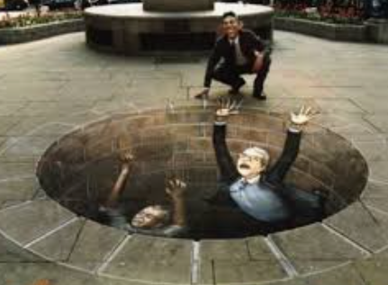  Diego Rivera  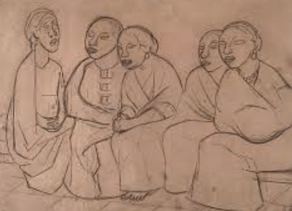  .  These two give a balance of illusion and perspective (Müller) and bold, narrative painting (Rivera). | Judith Scott  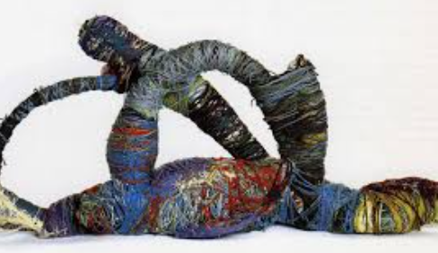  Louise Nevelson  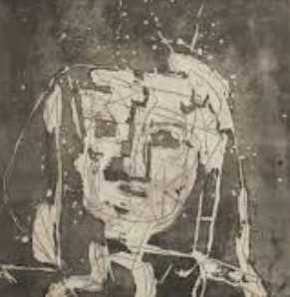  These two provide a balance of creative material exploration (Scott) and abstract structural design (Nevelson). | Cai Guo-Qiang  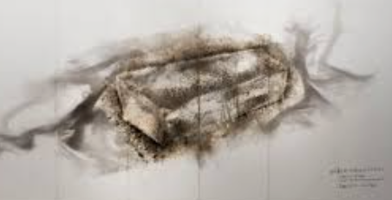  for explosive, large-scale artworks using unusual materials, inspiring pupils to experiment with scale, materials, and creative processes. | Vincent van Gogh  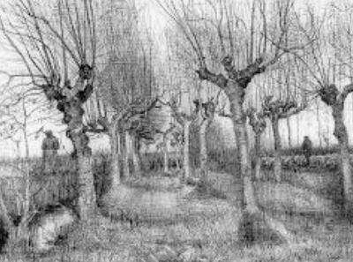  Frida Kahlo  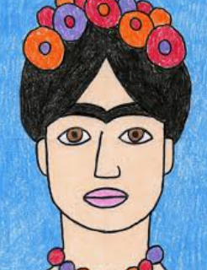  These two give a balance of expressive technique (van Gogh) and narrative, symbolic painting (Kahlo).

Reception

Reception
Half Term | Autumn Term |  | Spring Term |  | Summer Term
 | Cycle A | Cycle B | Cycle A | Cycle B | Cycle A | Cycle B
Planned  Opportunity | How can we use our bodies to make art?  Mark Making and Sound | How can we explore colour?  Printing with String  (Colour Mixing) | How can we explore 3D materials?  Insect Hotels | How can we explore 3D materials?  Fruit and Vegetable Heads | What can we see?  Still Life Compositions | How can we use our imaginations?  Imaginary Landscapes
Skills | - Talk about their ideas and explore different ways to record them using a range of media.  - Experiment in an exploratory way.  - Use a range of drawing materials, art application techniques, mixed-media scraps and modelling materials to create child-led art with no set outcome.  - Begin to develop observational skills (for example, by using mirrors to include the main features of faces).  - Enjoy looking at and talking about art.  - Talk about their artwork, stating what they feel they did well.  - Say if they like an artwork or not and begin to form opinions by explaining why. | - Talk about their ideas and explore different ways to record them using a range of media.  - Experiment in an exploratory way.  - Use a range of drawing materials, art application techniques, mixed-media scraps and modelling materials to create child-led art with no set outcome.  - Begin to develop observational skills (for example, by using mirrors to include the main features of faces).  - Enjoy looking at and talking about art. Talk about their artwork, stating what they feel they did well.  - Say if they like an artwork or not and begin to form opinions by explaining why. | - Talk about their ideas and explore different ways to record them using a range of media. Experiment in an exploratory way. Cut, thread, join and manipulate materials safely, focussing on process over outcome.  - Enjoy looking at and talking about art.  - Talk about their artwork, stating what they feel they did well. | - Use a range of drawing materials, art application techniques, mixed-media scraps and modelling materials to create child-led art with no set outcome. Cut, thread, join and manipulate materials safely, focussing on process over outcome. Begin to develop observational skills (for example, by using mirrors to include the main features of faces). Recognise that artists create varying types of art and use lots of different types of materials. | - Talk about their ideas and explore different ways to record them using a range of media.  - Experiment in an exploratory way.  - Use a range of drawing materials, art application techniques, mixed-media scraps and modelling materials to create child-led art with no set outcome.  - Enjoy looking at and talking about art.  - Recognise that artists create varying types of art and use lots of different types of materials.  - Recognise that artists can be inspired by many things.  - Talk about their artwork, stating what they feel they did well.  - Say if they like an artwork or not and begin to form opinions by explaining why. | - Talk about their ideas and explore different ways to record them using a range of media.  - Experiment in an exploratory way.  - Use a range of drawing materials, art application techniques, mixed-media scraps and modelling materials to create child-led art with no set outcome.  - Enjoy looking at and talking about art.  - Recognise that artists create varying types of art and use lots of different types of materials.  - Recognise that artists can be inspired by many things.  - Talk about their artwork, stating what they feel they did well.  - Say if they like an artwork or not and begin to form opinions by explaining why.
Knowledge | - Explore mark making using a range of drawing materials. Investigate marks and patterns when drawing. Identify similarities and difference between drawing tools. Investigate how to make large and small movements with control when drawing. Practise looking carefully when drawing. | - Explore mark making using a range of drawing materials. Investigate marks and patterns when drawing. Identify similarities and difference between drawing tools. Investigate how to make large and small movements with control when drawing. Practise looking carefully when drawing. | - Explore differences when cutting a variety of materials Investigate different ways of cutting eg. straight lines, wavy lines, zig-zags. Follow lines when cutting. Experiment with threading objects, holding equipment steady to do so. Explore techniques for joining paper and card eg stick, clip, tie, tape. Apply craft skills eg. cutting, threading, folding to make their own artworks. | - Use modelling tools to cut and shape soft materials eg. playdough, clay. Select and arrange natural materials to make 3D artworks. Talk about colour, shape and texture and explain their choices. | - Describe colours and textures as they paint. Explore what happens when paint colours mix. Make natural painting tools. Investigate natural materials eg paint, water for painting. Explore paint textures, for example mixing in other materials or adding water. Respond to a range of stimuli when painting. Use paint to express ideas and feelings. | - Describe colours and textures as they paint. Explore what happens when paint colours mix. Make natural painting tools. Investigate natural materials eg paint, water for painting. Explore paint textures, for example mixing in other materials or adding water. Respond to a range of stimuli when painting. Use paint to express ideas and feelings.
Disciplinary Knowledge  What pupils learn about how art is studied, discussed and judged | Begin to understand that Artists use different tools and materials to explore marks. Artists make choices about how to draw and what to draw. Marks can express ideas, emotions, or movement. Drawing is a process of exploring, noticing, and experimenting, not just copying. | learn that Artists explore and experiment by trying different marks (zig-zags, dots, swirls, wavy lines). They explore what happens when they draw fast, slow, soft, or hard. They select tools, materials, and movements based on what they want to show. | Discover that: Artists and designers explore materials by experimenting with different textures, colours, and materials. Artists make choices by selecting materials, colours, and techniques for a purpose. Artists join and manipulate materials by learning different ways to stick, fold, scrunch, or cut materials. | Learn how to be a sculptor by choosing and joining materials, trying different shapes, making sure it stands up, and showing your ideas through 3D creations. | learn how to be a painter by choosing colours and tools, exploring textures and patterns, mixing and layering paint, and showing your ideas and feelings through your work. | Learn how to try different brushes, tools, and materials to see the effects. They also explore how to select colours and tools depending on what they want to show. They will experiment that layering colours can change the effect
New Vocabulary  ‘Secure Six’ | Artist, colours, observe, zig zag, straight, Curved, | Artist, colours, observe, zig zag, straight, Curved, | Fix, flange, glue, slot, template, scrunch | 3D, design, evaluate, sculpture, collage, flatten | Collage, landscape, fixed, permanent, temporary, transient, | Collage, landscape, fixed, permanent, temporary, transient,
Impact Indicators  (Can demonstrate or answer using key vocabulary) | 1-Which tools or materials did you enjoy using the most? Why?  2- How did you make thick, thin, rough, or smooth marks?  3- What did you enjoy most about this lesson? | 1-Which tools or materials did you enjoy using the most? Why?  2- How did you make thick, thin, rough, or smooth marks?  3- What did you enjoy most about this lesson? | 1-Which craft techniques did you try (cutting, folding, weaving, sticking, wrapping, etc.)?  2-Which technique did you enjoy the most? Why?  3- What was tricky or challenging about today’s task? | 1-What did you make today?  2-What did you use to make it? (e.g., clay, boxes, sticks, playdough, foil)  3-How did you change the shape of your material? (squeeze, roll, press, twist, bend, stack) | 1-What did you paint here?  2-Which colours did you choose? Why?  3- What tools did you use to make your painting? (brush, sponge, fingers, etc.) | 1- How did you make your painting smooth, rough, or bumpy?  2-Did you use any other materials with your paint? (crayons, tissue, fabric, glue)  3-If you painted it again, what would you do differently?

Year 1/2
Year 1/2
Half Term | Autumn Term |  | Spring Term |  | Summer Term
 | Cycle A | Cycle B | Cycle A | Cycle B | Cycle A | Cycle B
Focus | Drawing: Understanding Tone and Texture | painting and mixed media: colour splash | Craft and Design: Woven Wonders | Sculpture and 3D: Paper play | Craft and Design: Map it out | Painting and mixed media: Life in colour
Skills | Beginning to generate ideas from a wider range of stimuli, exploring different media and techniques. Demonstrating increased control with a greater range of media. Developing observational skills to look closely and aim to reflect some of the formal elements of art (colour, pattern, texture, line, shape, form and space) in their work. Explaining their ideas and opinions about their own and others’ artwork, beginning to recognise the stories and messages within in and showing an understanding of why they may have made it. | Generating ideas:  Explore their own ideas using a range of media.  Using sketchbooks:  Use sketchbooks to explore ideas.  Making skills:  Develop some control when using a wide range of tools to draw, paint and create crafts and sculptures.  Make choices about which materials to use to create an effect.  Evaluating and analysing:  Describe and compare features of their own and others’ artwork.  Evaluate art with an understanding of how art can be varied and made in different ways and by different people. | Generating ideas:  Explore their own ideas using a range of media. Using sketchbooks:  Use sketchbooks to explore ideas. Making skills:  Develop some control when using a wide range of tools to draw, paint and create crafts and sculptures.  Make choices about which materials to use to create an effect. Explore and analyse a wider variety of ways to join and fix materials in place.  Knowledge of artists:  Describe similarities and differences between practices in Art and design, eg between painting and sculpture, and link these to their own work. Evaluating and analysing:  Describe and compare features of their own and others’ artwork. Evaluate art with an understanding of how art can be varied and made in different ways and by different people. | Generating ideas:  Explore their own ideas using a range of media. Using sketchbooks: Use sketchbooks to explore ideas. Making skills: Develop some control when using a wide range of tools to draw, paint and create crafts and sculptures. Explore and analyse a wider variety of ways to join and fix materials in place. Evaluating and analysing: Describe and compare features of their own and others’ artwork. Evaluate art with an understanding of how art can be varied and made in different ways and by different people. | Generating ideas: Begin to generate ideas from a wider range of stimuli, exploring different media and techniques. Using sketchbooks: Experiment in sketchbooks, using drawing to record ideas. Making skills: Further demonstrate increased control with a greater range of media. Use hands and tools with confidence when cutting, shaping and joining paper, card and malleable materials. | Generating ideas: Begin to generate ideas from a wider range of stimuli, exploring different media and techniques. Making skills: from a wider range of stimuli, exploring different media and techniques.  Making skills: Further demonstrate increased control with a greater range of media. Make choices about which materials and techniques to use to create an effect. Use hands and tools with confidence when cutting, shaping and joining paper, card and malleable materials. Develop observational skills to look closely and aim to reflect some of the formal elements of art (colour, pattern, texture, line, shape, form and space) in their work. Further demonstrate increased control with a greater range of media. Make choices about which materials and techniques to use to create an effect. Use hands and tools with confidence when cutting, shaping and joining paper, card and malleable materials. Develop observational skills to look closely and aim to reflect some of the formal elements of art (colour, pattern, texture, line, shape, form and space) in their work.
Knowledge | Using and describing more complex lines and marks that might begin to reflect texture, e.g. overlapping, varying speed and varying pressure. Recognising that shapes and marks can be refined rather than accepting the first attempt. Composing more complex drawings by combining shapes. Using shading to show light and dark areas. Using the same tool to colour/shade different tones by adjusting pressure. Developing spatial order by recognising objects in proportional relationship to each other, e.g. flowers are smaller than people. | - How to combine primary coloured materials to make secondary colours. How to mix secondary colours in paint. How to choose suitable sized paint brushes. How to clean a paintbrush to change colours. How to print with objects, applying a suitable layer of paint to the printing surface. How to overlap paint to mix new colours. How to use blowing to create a paint effect. How to make a paint colour darker or lighter (creating shades) in different ways eg. adding water, adding a lighter colour. | - What materials can be cut, knotted, threaded or plaited. How to wrap objects/shapes with wool. How to measure a length. How to tie a knot, thread and plait. How to make a box loom. How to join using knots. How to weave with paper on a paper loom. How to weave using a combination of materials. | - How to roll and fold paper. How to cut shapes from paper and card. How to cut and glue paper to make 3D structures. How to decide the best way to glue something. How to create a variety of shapes in paper, eg spiral, zig-zag. How to make larger structures using newspaper rolls. | - How to draw a map to illustrate a journey. How to separate wool fibres ready to make felt. How to lay wool fibres in opposite directions to make felt. How to roll and squeeze the felt to make the fibres stick together. How to add details to felt by twisting small amounts of wool. How to choose which parts of their drawn map to represent in their ‘stained glass’. How to overlap cellophane/tissue to create new colours. How to draw a design onto a printing polystyrene tile without pushing the pencil right through the surface. How to apply paint or ink using a printing roller. How to smooth a printing tile evenly to transfer an image. How to try out a variety of ideas for adapting prints into 2D or 3D artworks. | - How to mix a variety of shades of a secondary colour. How to make choices about amounts of paint to use when mixing a particular colour. How to match colours seen around them. How to create texture using different painting tools. How to make textured paper to use in a collage. How to choose and shape collage materials eg cutting, tearing. How to compose a collage, arranging and overlapping pieces for contrast and effect. How to add painted detail to a collage to enhance/improve it.
Disciplinary Knowledge  What pupils learn about how art is studied, discussed and judged | People make art to share their feelings and explore an idea in different ways. | - Art is made in different ways. Art is made by all different kinds of people. An artist is someone who creates. | - Art is made in different ways. Art is made by all different kinds of people. An artist is someone who creates. Craft is making something creative and useful. | - Art is made in different ways. Art is made by all different kinds of people. An artist is someone who creates. | - People use art to tell stories. People make art about things that are important to them. People make art to share their feelings. People make art to explore an idea in different ways. People make art for fun. People make art to decorate a space. People make art to help others understand something. | - People use art to tell stories. People make art about things that are important to them. People make art to share their feelings. People make art to help others understand something.
New Vocabulary  ‘Secure Six’ | Texture, tone, refine, shading, sketch, grip | Primary colour, secondary colour, blend, hue, mix, kaleidoscope | Craft, knot, loom, plait, threading, weaving, | Carving, concertina, loop, mosaic, overlap, spiral, | Abstract, composition, curator, overlap, stained glass, design brief | Collage, detail, mixing, surface, primary colour, secondary colour
Impact Indicators  (Can demonstrate or answer using key vocabulary) | 1- Which drawing tools did you use? (pencil, charcoal, chalk, pen, crayon)  2- How did you make light or dark areas in your drawing?  3-How did you create rough, smooth, bumpy, or soft textures? awing? | 1-What patterns did you make in your artwork?  2-How did mixing colours change your painting?  3-If you painted this again, what would you do differently? | 1-Which materials did you use for weaving? (paper, fabric, ribbons, wool, etc.)  2- Which weaving techniques did you try? (over, under, looping, braiding)  3-What was the easiest part of weaving? And what was the trickiest part? | 1-Can you show me where you folded or curled your paper?  2-Which textures did you make in your sculpture?  3-How did you join pieces of paper together?  4-Which shapes or forms are in your sculpture?  5-How did you layer or build your sculpture? | 1-How did you plan your map before starting?  2-Did you try any new ideas or materials today?  3-If you made another map, what would you do differently?  4- How did you solve problems when something didn’t stick or work? | 1-How did you decide what to paint and which colours to use?  2-Did you try any new techniques or ideas today?  3-If you painted this again, what would you do differently?  4- Did you change your painting while working on it? How?

Year 3/4
Year 3/4
Half Term | Autumn Term |  | Spring Term |  | Summer Term
 | Cycle A | Cycle B | Cycle A | Cycle B | Cycle A | Cycle B
Focus | Craft and design: Fabric of nature | Drawing: Developing drawing skills | Craft and design: Ancient Egyptian scrolls | Sculpture and 3D: Abstract shape and space | Painting and mixed media- prehistoric painting | Painting and mixed media- Light and Dark
Skills | Generating ideas: Generate ideas from a range of stimuli, using research and evaluation of techniques to develop their ideas and plan more purposefully for an outcome. Using sketchbooks: Use sketchbooks for a wider range of purposes, for example, recording things using drawing and annotations, planning and taking the next steps in a making process. Making skills: Demonstrate greater skill and control when drawing and painting to depict forms, such as showing an awareness of proportion and being able to create 3D effects. Use growing knowledge of different materials, combining media for effect. | Generating ideas:  Generating ideas from a range of stimuli and carrying out simple research and evaluation as part of the making process.  Using sketchbooks:  Using sketchbooks for a wider range of purposes, for example recording things using drawing and annotations, planning and taking next steps in a making process.  Making skills:  Confidently using a range of materials and tools, selecting and using these appropriately with more independence.  Developing direct observation, for example by using tonal shading and starting to apply an understanding of shape to communicate form. | Generating ideas: Generate ideas from a range of stimuli and carry out simple research and evaluation as part of the making process. Using sketchbooks: Use sketchbooks for a wider range of purposes, for example recording things using drawing and annotations, planning and taking next steps in a making process. Making skills: Confidently use of a range of materials and tools, selecting and using these appropriately with more independence. Use hands and tools confidently to cut, shape and join materials for a purpose. Develop direct observation, for example by using tonal shading and starting to apply an understanding of shape to communicate form and proportion. | Generating ideas: Generate ideas from a range of stimuli and carry out simple research and evaluation as part of the making process. Making skills:  Confidently use of a range of materials and tools, selecting and using these appropriately with more independence.  Use hands and tools confidently to cut, shape and join materials for a purpose. | Generating ideas:  Generate ideas from a range of stimuli and carry out simple research and evaluation as part of the making process. Using sketchbooks: Use sketchbooks for a wider range of purposes, for example recording things using drawing and annotations, planning and taking next steps in a making process. Making skills: Develop direct observation, for example by using tonal shading and starting to apply an understanding of shape to communicate form and proportion. Confidently use a range of materials and tools, selecting and using these appropriately with more independence. Knowledge of artists: Discuss how artists produced art in the past and understand the influence and impact of their methods and styles on art today, using their own experiences and historical evidence.  Understand the limitations of tools and materials and be able to experiment within more than one medium and with tools to create textural effects. | Generating ideas: Generate ideas from a range of stimuli, using research and evaluation of techniques to develop their ideas and plan more purposefully for an outcome. Using sketchbooks: Use sketchbooks for a wider range of purposes, for example, recording things using drawing and annotations, planning and taking the next steps in a making process.  Making skills: Demonstrate greater skill and control when drawing and painting to depict forms, such as showing an awareness of proportion and being able to create 3D effects. Apply observational skills, showing a greater awareness of composition and demonstrating the beginnings of an individual style.
Knowledge | To know that a mood board is a visual collection which aims to convey a general feeling or idea. To know that batik is a traditional fabric decoration technique that uses hot wax. How to select imagery and use it as inspiration for a design project. How to make a mood board. How to recognise a theme and develop colour palettes using selected imagery and drawings. How to draw small sections of one image to docs on colours and texture. How to develop observational drawings into shapes and patterns for design. How to transfer a design using a tracing method. How to make a repeating pattern tile using cut and torn paper shapes. How to use glue as an alternative batik technique to create patterns on fabric. How to use materials, like glue, in different ways depending on the desired effect. How to paint on fabric. How to wash fabric to remove glue to finish a decorative fabric piece. | Use and apply more complex lines and marks to represent texture, tone, pattern, etc, and describe their qualities, e.g. thick and thin. Recognise more organic shapes within objects. Attempt to draw 3D forms using line and shape. Place tonal shading by experimenting and recognising how it can help to show that a shape has form. Sketch out an idea or composition using short, fast, light strokes and 2D shapes. | - Layering materials in opposite directions make the handmade paper stronger. How to use a sketchbook to research a subject using different techniques and materials to present ideas. How to construct a new paper material using paper, water and glue How to use symbols to reflect both literal and figurative ideas. How to produce and select an effective final design. How to make a scroll. How to make a zine. How to use a zine to present information. | - How to join 2D shapes to make a 3D form. How to join larger pieces of materials, exploring what gives 3D shapes stability. How to shape card in different ways eg. rolling, folding and choose the best way to recreate a drawn idea. How to identify and draw negative spaces. How to plan a sculpture by drawing. How to choose materials to scale up an idea. How to create different joins in card eg. slot, tabs, wrapping. How to add surface detail to a sculpture using colour or texture. | - How to use simple shapes to scale up a drawing to make it bigger. How to make a cave wall surface. How to paint on a rough surface. How to make a negative and positive image. How to create a textured background using charcoal and chalk. How to use natural objects to make tools to paint with. How to make natural paints using natural materials. How to create different textures using different parts of a brush. How to use colour mixing to make natural colours. | - How to mix a tint and a shade by adding black or white. How to use tints and shades of a colour to create a 3D effect when painting. How to apply paint using different techniques e.g. stippling, dabbing, washing. How to choose suitable painting tools. How to arrange objects to create a still-life composition. How to plan a painting by drawing first. How to organise painting equipment independently, making choices about tools and materials.
Disciplinary Knowledge  What pupils learn about how art is studied, discussed and judged | Artists make choices about what, how and where they create art. Art can be created to make money; being an artist is a job for some people. Art, craft and design affect the lives of people who see or use something that has been created. Artists evaluate what they make, and talking about art is one way to do this. | Confidently explaining their ideas and opinions about their own and others’ artwork, with an understanding of the breadth of what art can be and that there are many ways to make art. | Confidently explain their ideas and opinions about their own and others’ artwork, with an understanding of the breadth of what art can be and that there are many ways to make art.  Discuss and begin to interpret the meaning and purpose of artwork, understanding how artists can use art to communicate. | Confidently explain their ideas and opinions about their own and others’ artwork, with an understanding of the breadth of what art can be and that there are many ways to make art.  Discuss and begin to interpret the meaning and purpose of artwork, understanding how artists can use art to communicate. | Confidently explain their ideas and opinions about their own and others’ artwork, with an understanding of the breadth of what art can be and that there are many ways to make art.  Discuss and begin to interpret meaning and purpose of artwork, understanding how artists can use art to communicate. | - Artists make choices about what, how and where they create art. Artworks can fit more than one genre. Art is influenced by the time and place it was made, and this affects how people interpret it. Artists may hide messages or meaning in their work.
New Vocabulary  ‘Secure Six’ | Batik, inspiration. Colour pallet, symmetrical, organic, theme | Blend, even tone, observation, organic, product, illustrator | Papyrus, layout, imagery, convey, scale, zine | Abstract, found objects, negative space, positive space, sculptor, structure | Charcoal, pigment, proportion, smudging, sketch, scaled up | Dabbing paint, shadow, figurative, pointillism, tint, vivid,
Impact Indicators  (Can demonstrate or answer using key vocabulary) | 1-How did you plan your textile artwork before starting?  2- Did you try any new techniques or ideas here?  3-Which fabrics or materials did you choose and why?  4-Can you show me the textures you created?  5-How did you layer or join your fabrics? | 1-If you could draw this again, what would you do differently?  2-How did you solve problems when a mark or proportion didn’t look right?  3- Can you show me where you used hatching or cross-hatching?  4-How did you blend marks to change the tone?  5-Which lines show light, dark, or texture in your drawing?  6-How did you show proportion in your drawing? | 1-Did you use layering or combining materials? How did it help your design?  2- If you made another scroll, what would you do differently?  3-How did you solve problems when your materials didn’t work as planned?  4-How did your scroll change as you worked on it?  5-Which symbols or hieroglyphs did you include, and why?  6- How did you layer or combine materials on your scroll? | 1-How did you join or assemble your materials?  2-If you made your sculpture again, what would you do differently?  3-How did you solve problems when parts didn’t fit or stand properly?  4-Did you explore space between shapes in your sculpture? How?  5-How did you make your sculpture stand or stay balanced?  6-How does your sculpture use space around and between shapes? | 1-Did you try any special techniques to make marks or textures?  2-What textures did you try to create in your painting?  3-How did your painting show movement, action, or story?  4-Which parts of your painting show your favourite techniques?  5-How did your painting tell a story about prehistoric life?  6-How did you create textures for rocks, animals, or humans? | 1-Did you layer or blend colours to make your light and dark areas?  2-How did you make the dark areas look stronger or deeper?  3-Did you create any textures in your painting? How?  4-How did you solve problems when blending or layering colours didn’t work?  5- How did you blend or layer your colours to make tone?  6-Where did you use texture in your painting?  7-Which areas show contrast the most?

Year 5/6
Year 5/6
Half Term | Autumn Term |  | Spring Term |  | Summer Term
 | Cycle A | Cycle B | Cycle A | Cycle B | Cycle A | Cycle B
Focus | Craft and design: Architecture | Drawing: Make my voice heard | Drawing: Expressing ideas | Sculpture and 3D: Making memorise | Sculpture and 3D : Interactive Installation | Y5 Painting and mixed media- portraits
Skills | Generating ideas: Develop ideas more independently from their own research. Explore and record their plans, ideas and evaluations to develop their ideas towards an outcome. Using sketchbooks:  Confidently use sketchbooks for purposes including recording observations and research, testing materials and working towards an outcome more independently. Making skills: Work with a range of media with control in different ways to achieve different effects, including experimenting with the techniques used by other artists.  Create in a more sustained way, revisiting artwork over time and applying their understanding of tone, texture, line, colour and form. | Generating ideas: Draw upon their experience of creative work and their research to develop their own starting points for creative outcomes. Using sketchbooks:  Using a systematic and independent approach, research, test and develop ideas and plans using sketchbooks. Making skills:  Create expressively in their own personal style and in response to their choice of stimulus, showing the ability to develop artwork independently Combine materials and techniques appropriate to fit with ideas. Work in a sustained way over several sessions to complete a piece, including working collaboratively on a larger scale and incorporating the formal elements of art. | Describing, interpreting and evaluating the work, ideas and processes used by artists across a variety of disciplines, being able to describe how the cultural and historical context may have influenced their creative work. Making skills: Create expressively in their own personal style and in response to their choice of stimulus, showing the ability to develop artwork | Describe, interpret and evaluate the work, ideas and processes used by artists across a variety of disciplines, being able to describe how the cultural and historical context may have influenced their creative work. Recognise how artists use materials to respond to feelings and memory and choose materials, imagery, shape and form to create personal pieces. Understand how art forms such as photography and sculpture continually develop over time as artists seek to break new boundaries. | Generating ideas: Develop ideas more independently from their own research. Explore and record their plans, ideas and evaluations to develop their ideas towards an outcome. Using sketchbooks: Confidently use sketchbooks for purposes including recording observations and research, testing materials and working towards an outcome more independently. Making skills: Work with a range of media with control in different ways to achieve different effects, including experimenting with the techniques used by other artists. | Generating ideas:  Develop ideas more independently from their own research. Explore and record their plans, ideas and evaluations to develop their ideas towards an outcome. Using sketchbooks:  Confidently use sketchbooks for purposes including recording observations and research, testing materials and working towards an outcome more independently. Making skills: Work with a range of media with control in different ways to achieve different effects, including experimenting with the techniques used by other artists.  Combine a wider range of media, e.g. photography and digital art effects.  Create in a more sustained way, revisiting artwork over time and applying their understanding of tone, texture, line, colour and form.
Knowledge | - To know the steps to make a monoprint when a roller is sufficiently inked. How to make an observational drawing of a house. How to use shapes and measuring as methods to draw accurate proportions. How to select a small section of a drawing to use as a print design. How to develop drawings further to use as a design for print. How to design a building that fits a specific brief. How to draw an idea in the style of an architect that is annotated to explain key features. How to draw from different views, such as a front or side elevation. How to use sketchbooks to research and present information about an artist. How to interpret an idea in into a design for a structure. | - To know gestural and expressive ways to make marks. To know the effects different materials, make. To know the effects created when drawing on different surfaces. How to use symbolism as a way to create imagery. How to combine imagery into unique compositions. How to achieve the tonal technique called chiaroscuro. How to make handmade tools to draw with. How to use charcoal to create chiaroscuro effects. | - Explore the expressive qualities of line as part of their iterative process. Consider the desired line quality in their artwork and thoughtfully choose materials and techniques to best achieve this effect. Further develop shading techniques by creatively selecting and combining tools and techniques to align with their artistic intentions. Find a point in the distance to draw from (one-point perspective). Scale drawings up or down while aiming to keep proportion. | - How to translate a 2D image into a 3D form. How to manipulate cardboard to create 3D forms (tearing, cutting, folding, bending, ripping). How to manipulate cardboard to create different textures. How to make a cardboard relief sculpture. How to make visual notes to generate ideas for a final piece. How to translate ideas into sculptural forms. | - How to make an explosion drawing in the style of Cai Guo-Quang, exploring the effect of different materials. How to try out ideas on a small scale to assess their effect. How to use everyday objects to form a sculpture. How to transform and manipulate ordinary objects into sculpture by wrapping, colouring, covering and joining them. How to try out ideas for making a sculpture interactive. How to plan an installation proposal, making choices about light, sound and display. | - How to develop a drawing into a painting. How to create a drawing using text as lines and tone. How to experiment with materials and create different backgrounds to draw onto. How to use a photograph as a starting point for a mixed-media artwork. How to take an interesting portrait photograph, exploring different angles. How to adapt an image to create a new one. How to combine materials to create an effect. How to choose colours to represent an idea or atmosphere. How to develop a final composition from sketchbook ideas.
Disciplinary Knowledge  What pupils learn about how art is studied, discussed and judged | Discuss the processes used by themselves, and by other artists, and describe the particular outcome achieved. | - Discuss how art is sometimes used to communicate social, political, or environmental views. Explain how art can be created to cause reaction and impact and be able to consider why an artist chooses to use art in this way. | - Explaining how art can be created to cause reaction and impact and being able to consider why an artist chooses to use art in this way. Independently using their knowledge of tools, materials and processes to try alternative solutions and make improvements to their work. | - Art doesn’t have to be a literal representation of something; it can sometimes be imagined and abstract. Art can represent abstract concepts, like memories and experiences. Sometimes people make art to express their views and opinions, which can be political or topical. | - Discuss the processes used by themselves and by other artists, and describe the particular outcome achieved. Use their knowledge of tools, materials and processes to try alternative solutions and make improvements to their work. | - Discuss the processes used by themselves and by other artists, and describe the particular outcome achieved. Use their knowledge of tools, materials and processes to try alternative solutions and make improvements to their work.
New Vocabulary  ‘Secure Six’ | Annotate, commemorate, design brief, elevation, external, futuristic, monoprint | Aesthetic, chiaroscuro, graffiti, mural, street art,  guerrilla | Depth, horizon, graffiti, realism, vanishing point, one-point perspective | Assemblage, attribute, juxtaposition, literal, pitfall, symbolic | Concept, elements, interact, performance art, installation art, special effect | Art medium, carbon paper, continuous line drawing, mixed media, self-portrait justify,
Impact Indicators  (Can demonstrate or answer using key vocabulary) | 1-Which materials did you use to make your model?  2-How did you make your building stable or strong?  3-Did you explore symmetry, balance, or proportion in your design?  4-If you could redesign your model, what would you do differently?  5- How did you solve problems when pieces didn’t fit or balance?  6-How did you use layers or joins in your model?  7-How did you include symmetry or balance in your design?  8-Which details did you add to make it more interesting? | 1-Which techniques did you use to express your message? (line, shading, layering, mark-making, colour)  2- How did your choice of lines or marks help express your idea?  3-How do you think someone else might understand your drawing?  4-If you drew it again, what would you do differently?  5-Which colours or tones make your message stronger?  6-Did you include any symbols or patterns?  7-How did layering marks or media affect your drawing? | 1-Which techniques did you try to show your idea? (line, shading, mark-making, layering, perspective)  2-How did your choice of marks, lines, or shapes help express your idea?  3- Did you include any symbols or patterns to support your message?  4-If you could do it again, what would you do differently?  5-How did you solve problems when something didn’t look right?  6-How did layering or different techniques help your drawing?  7-How does your drawing communicate your idea to someone else? | 1-Which materials did you use to create your sculpture? (clay, wire, paper, cardboard, mixed media)  2-How did you plan your sculpture before starting?  3-How did you create textures in your sculpture?  4-Did you combine or layer different materials? How did it affect your sculpture?  5-How does your sculpture show meaning or tell a story?  6-How did you solve problems when pieces didn’t fit or materials didn’t work as planned?  7-Which shapes or forms did you use to show your memory?  8-How did you create textures in your sculpture? | 1-Which materials did you use? (card, wire, fabric, recycled materials, mixed media)  2- How did you plan your installation before starting?  3-How do people interact with your installation? (move around it, touch it, explore it)  4-How did you combine or layer materials to create effects?  5-How do the forms, shapes, or textures make your installation interesting?  6-What part of your installation are you most proud of?  7-How does your installation use space around it? | 1-Which materials and tools did you use? (paints, brushes, pencils, pastels, mixed media)  2- How did you plan your portrait before starting?  3-How did you use light and dark to show tone or depth?  4-How did you create textures for hair, clothing, or skin?  5- How did you show expression or personality in your portrait?  6-How did you use layers or mixed media?  7-How did you show expression or personality?  8-How did you make your portrait proportional and realistic?

